March 28, 2022

Dr. Donald R. Bobbitt
Charles E, Scharlau Presidential Leadership Chair
University of Arkansas System
2404 N. University Ave.
Little Rock, AR 72207-3608

RE: Proposed UAMS Campus Assembly Constitution Revision

Dear Dr. Bobbitt,

The faculty of the University of Arkansas for Medical Sciences (UAMS) recently voted to approve revisions to the Constitution of the Campus Assembly for our institution.

The Academic Senate in collaboration with the House of Delegates, which together make up the Campus Assembly, reviewed the campus constitution for the purpose of improving the effectiveness of faculty and staff governance on campus. The Senate will continue to serve as a mechanism for voicing faculty feedback and recommendations on issues of faculty affairs and academic policies and how the Senate can collaborate with the Provost to work toward strong faculty engagement and excellence in the UAMS academic mission to the state of Arkansas. Amendments approved by the Academic Senate and the House of Delegates (HOD) are more reflective of current operations of the group and to more efficiently focus the campus governance on faculty affairs issues.

Two notable changes were approved by these two bodies. First, the composition of the Academic Senate has been amended to be an elected body instead of being composed of essentially all persons with faculty appointments at UAMS. Second, in recognition of existing curricular and degree oversight of the individual colleges with their own accrediting bodies, the function of the Academic Senate has been revised. It is proposed that oversight of degree programs, curricula, calendars and honors be removed consistent with current practices. The Academic Senate will continue to be focused on issues of faculty affairs. Other more modest amendments to the constitution include adjustments to the standing committees, Senate attendance, eliminating departmental/college quotas for the HOD, allowing non-elected members to serve on the HOD and modernizing the language. The amendments also cover election of Senate representatives in each college and added new representatives for the Division of Academic Affairs.

Prior to the full Academic Senate faculty vote approving the amendments on Nov. 2, 2021 (121-yeah; 11-nay), the proposal was approved by the Academic Senate Council on Sept. 21, 2021 and discussed at two previous open Academic Senate Council meetings. Similarly, the House of Delegates executive committee included the amendments on two consecutive agenda meetings and the full House of Delegates approved the amendments on Oct. 20, 2021 by voice vote. Academic Senate officers also shared the proposed revisions with Provost Stephanie Gardner, who in turn circulated the proposal to the Office of the General Counsel at UAMS and at the System Office. The proposed revisions were consistent with campus policies and seen as promoting an engaged faculty community.

I agree with the revised Constitution as approved. I ask you to review the proposal — which includes a draft marked with the proposed changes and a “clean” version of the revised document as approved. If you agree, please add the proposal to the agenda for the May meeting of the Board of Trustees.

Sincerely,

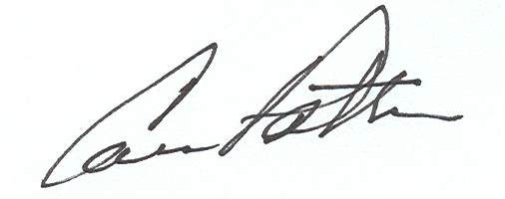

Cam Patterson, M.D., MBA
Chancellor

Cc: Dr. Stephanie Gardner
Dr. Priya Mendiratta
Dr. Bradley Martin
Dr. Tiffany Huitt

Page 2
Board of Trustees Agenda Request — Revised Campus Constitution Proposal
03-28-2022

